**BIRDS GAME DOCUMENTATION**

Given the team assignment “Build an app displaying a flock of flappy birds” by Mr. Khang, team ProVision has worked together and now let us introduce a product of minigame written in C# on Winforms model, based on the topic, accompanied by bonus techniques and creative functions which make the project lively. This is the detailed documentation of the application.

**0/ General intro:**

BIRDS is built on the foundation of mixed knowledge about GUI and GDI in the subject of Visual Programming, combined with understanding of physics (collision, fall handling,…) in order to logicalize object – event term.

The Game includes instructions as well as simple control, which helps users approach conveniently.

Source code is set up as clean as possible, which serves the need for repair, maintenance and development.

**1/ Notes before running:**

- You should build the app by Visual Studio 2017 or newer, if not possible, download .NET Framework 4.7.2 Developer Pack.

- You can run game directly through the file **bird.exe** in folder **runnable**. Warning: the Game cannot be executed if there is a lack of these files: sprite **bird_sprite.png**, **frontCloud.png**, **backCloud.png**

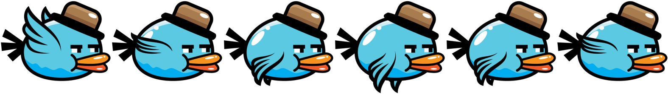



- If still unable to build, check if there are three of the files above in the folder Debug of bin, otherwise copy those files from folder runnable.

- Refresh mind to enjoy the Game of us

**2/ UI elements:**

- **Background effect:** On running the Game, the current background of user’s computer will be screenshotted and become the real background of the Game. This feature creates a feeling of “playing the game straight on the user’s present window”. ***This Background is saved as a file in the Game folder and automatically deleted when you exit the game.***

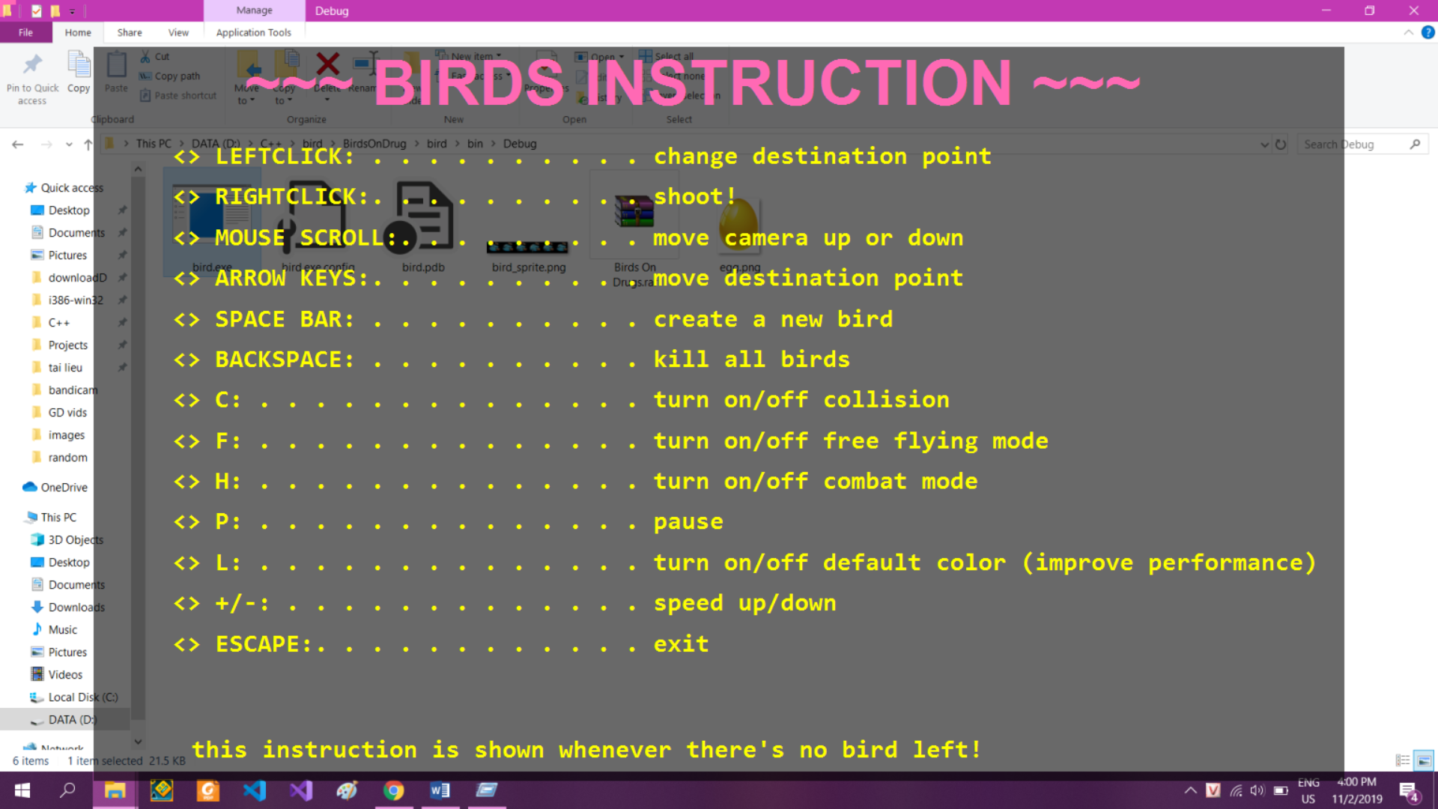

- **Instruction:** appears whenever there is no bird left. There you can read the basic control to interact with the game. Forget what to do? Just press Backspace to kill all birds and the instruction is on again.

- **Screen:** Once a bird is generated, the instruction is off. The current window is the flying space of the birds! This area is very wide and seems to stretch infinitely when mouse scrolling upward or downward.

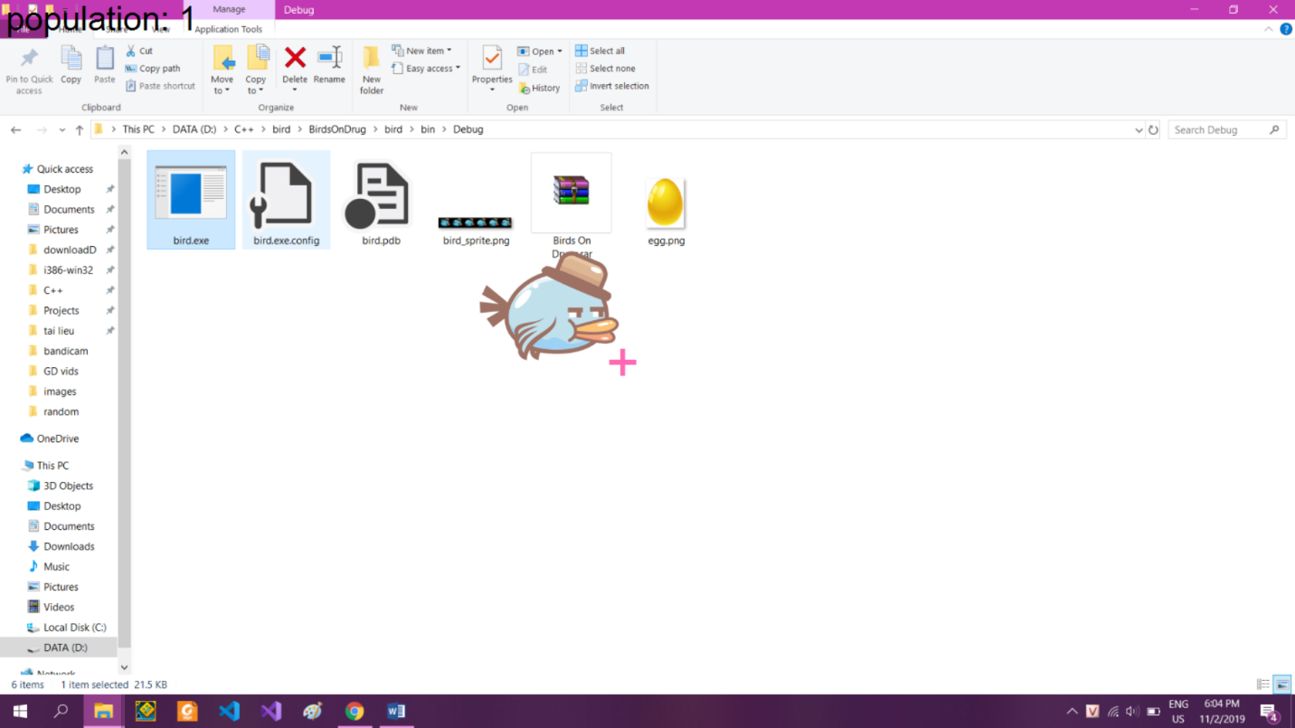

- **Plus sign:** the pink plus sign on the screen is the target that all birds are moving towards (destPos). The default position is the exactly center point of the screen.

- **Population:** on the top left position of the screen, displaying the current number of birds. This number may be very large (depends on your computer)

- **Clouds Effect:** flowing cloudy effect makes the Game more virtual. There are two kinds of clouds: front cloud and back cloud.

- To enter the game, press Space Bar and a bird appears.

**3/ Mechanism:**

- Any bird is generated with different value of parameters in order to establish a variety of behaviors and interaction with other birds:

+ ***Force:*** tells the amount of force when the bird flies towards the target point.

+ ***Friction:*** tells whether the bird is much or less affected by air resistance.

+ ***Radius:*** tells the size of the bird. Every bird has a circle hitbox, this value is the radius of the circle.

+ ***ColForce (collision force):*** birds colliding with others creates a force, which makes them move backward according to a certain vector.

+ ***Mass:*** the weight the bird. Based on mass and the forces to **calculate the acceleration**.

+ ***Level of aimlessness:*** tells the flipping side frequency of the bird in free flying mode (explain later). The more aimlessness the higher frequency of the bird.

+ ***FreForce (free force):*** tells the flying force of the bird in free flying mode.

+ ***Health:*** birds will hit each other in combat mode (explain later), health tells whether the bird can exist long enough or not.

+ ***Defence:*** any bird has its own defense ability, which reduces the amount of damage taken.

+ Value of color generation (rT, gT, bT) is set up based on the parameters: flying force, collision force, mass

**- Physics in the game is handled through principles of classical mechanics (three laws of Newton). Collision and fall events are really logical (even when a bird is out of the game)**

- **Health point rule:** on collision with others, the bird will be affected by force, based on the third law of Newton. However, each bird will take a particular penalty of health point reduction (calculated from the defense and collision force of the other birds.

- **Awards:** if bird A is the one that last hits bird B, it will be rewarded an amount of lost health point.

In addition, the nearer a bird is from the target point, the more HP it will be added every frame; otherwise, too far from the target point, its HP will be drained.

- ***Is death over?*** A bird is considered to be completely out of the game only when two requirements is met:

+ It runs out of health point in combat mode or it is shot by you

+ Its corpse reaches a certain height downwards and its soul reaches a certain height upwards

So when the population is 0 and the instruction does not appear, wait for some seconds

**4/ Interaction:**

- **Left click:** you can click any point on the screen, then move around to control your desired destination. You can click again at a certain point to stick the mouse there. All the birds will fly towards that point (except when free flying mode is enabled)

In addition, drag and drop is allowed for the same function.

- **Right click:** you can shoot any bird that you want (because you hate it or something) by right clicking on it.

- **Mouse Scrolling:** you can move the camera upward or downward by simply scrolling the mouse. The flying space seems to be infinite vertically.

- **Arrow key:** another way to control the target point

- **SpaceBar:** to generate a newborn bird

- **Backspace:** kill all birds (because you hate ‘em or something)

- **C key:** turn on/off the collision mode. If it is off, the birds stop hitting one another and can be overlapped.

- **F key:** turn on/off the free flying mode. If it is off, the birds will fly freely on the sky (not follow the target point)

- **H hey:** turn on/off the combat mode. If it is on, each bird will have a health point bar below, and can affect others’ health point. The bar will change color from green to red depending on the health status. If a bird runs out of health point, it will be out of the game.

- **P key:** pause game. You can still interact with the birds through other control. Often used to observe one bird.

- **L key:** turn on/off the coloring mode. If it is off, the speed of performance will be improved very much (no lagging situation when genearate a new bird)

- **Esc key:** exit game

**5/ Techniques:**

A lot of procedures are applied, but revolve around 3 main techniques:

**- Event handling:** GUI programming in C# to interact with user

**- Animation + graphics handling:** GDI+ programming in C# with many tools. The Double Buffering is efficiently used for dealing with graphics flicker.

**- Physical implementation:** self-defined variables, methods, flexible to handle purely-physical collision, fall.

Besides, some little special components are added by us, for example: direct screenshot for background as well as flowing cloudy effects (relative speed, position,…) to beautify user interface (UI), and better user experience (UX).

Have good experience with our game <3

A product of Team ProVision

Lê Hoàng Minh Sơn – 18520350

Quản Tiến Nghĩa – 18520111

Võ Thành Trung – 18520180

Hà Minh Trường - 18520181